

Course: Digital Marketing
Group: 02
Name | Roll Number
Somtirtha Pal | P2522072
Shrijita Das | P2521070
Suvayan Dey | P2522076
Souparno Karmakar | P2521074
Utsav Banerjee | P2521085
Mayank Somnathe | P2521048
Shahil Verma | P2522061
Anirudha Nath | P2522007
Prateek Kushwaha | P2521058
Apurva Badola | P2522011
Subhadeep Sinha | P2521078
M Praveen Kumar | P2522036
Karan Kamath | P2522029
Dhruv Mathur | P2521034
Anusha Agarwal | P2522009
Ananth Papewar | P2522005

THREE AI TOOLS & THEIR USE CASES IN DIGITAL MARKETING:

- MIDJOURNEY AI:
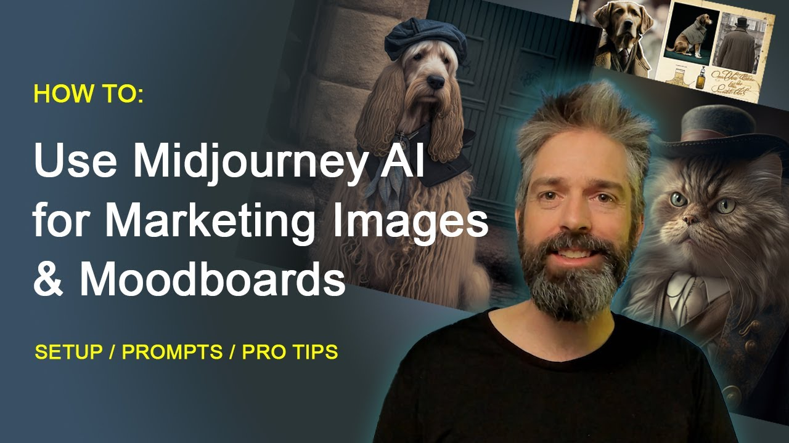

• Creates high-quality marketing visuals from text prompts.
Midjourney allows digital marketers to produce ad-quality images simply by describing what they want. Instead of arranging photoshoots or depending on designers, the marketer writes a prompt like “Premium skincare ad in soft pastel lighting with minimal design”. The tool instantly produces multiple variations. This helps brands test different creative styles much faster and at almost zero cost.
• Helps marketers’ experiment with multiple ad concepts quickly.
Brands can create 20–30 design variations in minutes and use them for A/B testing. For example, an e-commerce brand can test whether lifestyle shots, minimalistic shots, or bold-color product shots perform better in Instagram ads. Midjourney dramatically speeds up the experimentation phase of campaign planning.
• Reduces campaign production cost and time.
Traditional creative production involves photographers, studio time, editing, and revisions. Midjourney bypasses all of this, allowing marketers to create campaign-ready visuals quickly. This is especially useful for startups or small teams with limited budgets.

- CANVA AI:
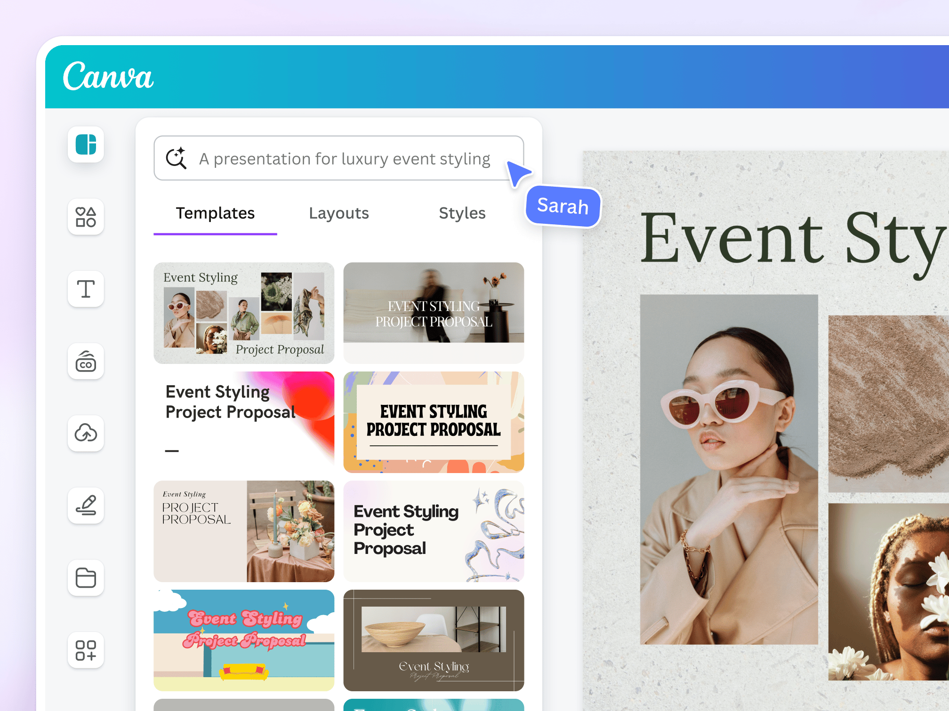

• Instantly generates platform-specific ad designs.
Canva AI takes a single product image or brief and automatically produces ads tailored for Instagram, Facebook, LinkedIn, YouTube, and Stories & Reels. This saves marketers from manually resizing and redesigning the same creative for different placements.
• Helps non-designers create professional brand-compatible content.
The tool offers ready-made templates with correct color palettes, aligned fonts, and modern layouts. Even if someone has no design experience, Canva AI ensures the final output looks professional and consistent with brand identity—which is essential for digital marketing.
• Automatically writes captions, headlines, and creative copy
Using its Magic Write features, Canva AI suggests catchy headlines, hooks, and post descriptions. For example, if a marketer uploads a picture of a new coffee product, the tool can generate captions like “A richer brew for your mornings is now available”. This speeds up social media content creation without relying on a copywriter.

- NOTEBOOK LM:
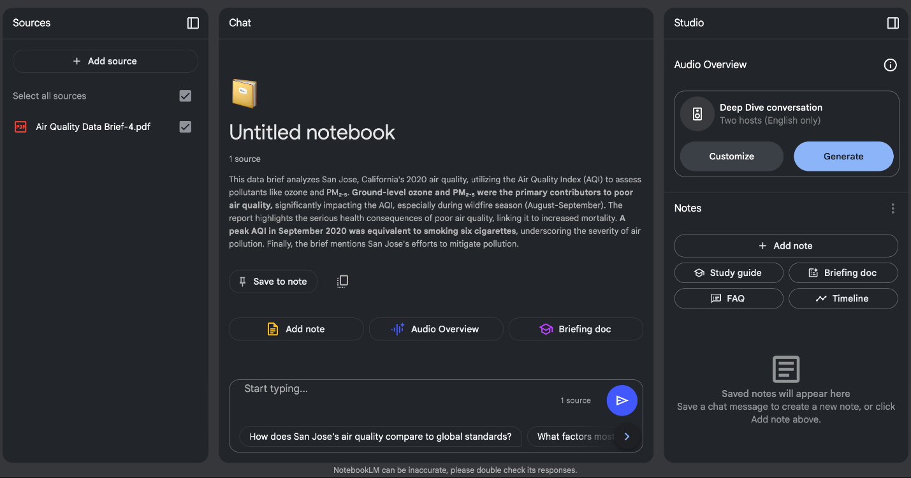

1. Source-Grounded AI Answers
Notebook LM gives responses based only on the documents you upload, ensuring accurate, trustworthy, and context-specific information.

2. Instant Summaries & Insights
It quickly converts long PDFs, articles, and notes into clear summaries, key points, FAQs, and simplified explanations.

3. AI Workspace for Research & Writing
You can chat with your documents, generate reports, drafts, and ideas—all inside one centralized, intelligent workspace.

5 FACEBOOK /INSTAGRAM ADS OF OUR CHOICE:

- ZOMATO:
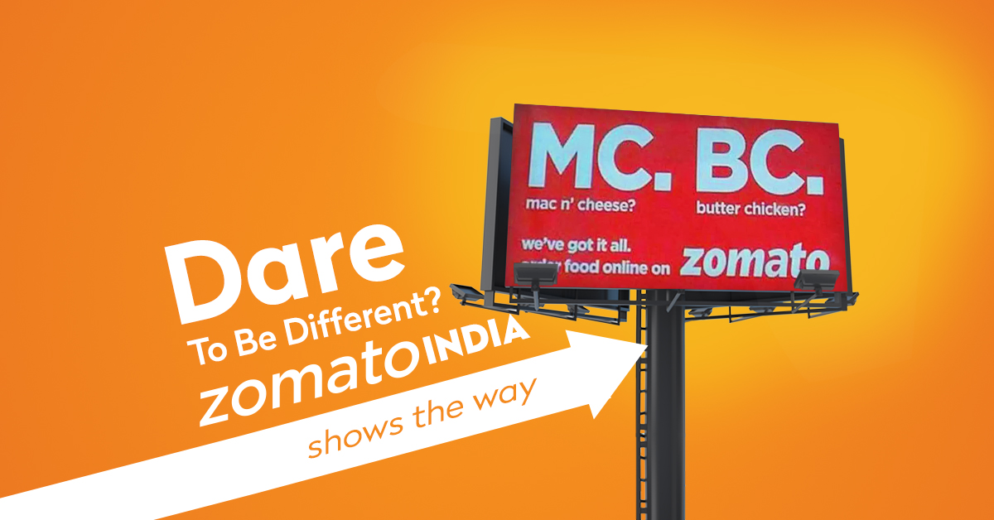
• Format: Static image with bold colors and humorous copy.
Zomato frequently uses bright red backgrounds with witty one-liners that grab attention instantly. Static images load fast and work well on Instagram feeds.
• Targeting: Urban users aged 18–35 who browse food content.
This ad likely targets people who follow food pages, search for restaurants, or frequently use delivery apps. Instagram behavioral data helps Zomato reach users who are hungry or interested in dining out.
• Learning: Humor + simplicity improves engagement.
Zomato proves that ads don’t need heavy design. A simple joke and strong brand color can outperform complex creatives.
• CTA: “Order Now”.
A direct CTA encourages immediate conversions since food delivery is an impulse-driven category.

- NIKE:


• Format: Short 8–12 second performance video.
Nike uses fast-paced athletic clips showing people running, training, or using new Nike shoes. Video format conveys energy and emotion better than images.
• Targeting: Fitness enthusiasts, gym-goers, and sports audiences.
Facebook tracks interests like running, workout pages, or sports influencers. Nike uses this data to target users already interested in fitness products.
• Learning: Motion content drives higher engagement in sports niche.
Short videos outperform static images because they create an emotional connection and demonstrate product functionality.
• CTA: “Shop Now”.
Encourages viewers to check the product immediately, especially when paired with dynamic storytelling

- BOAT
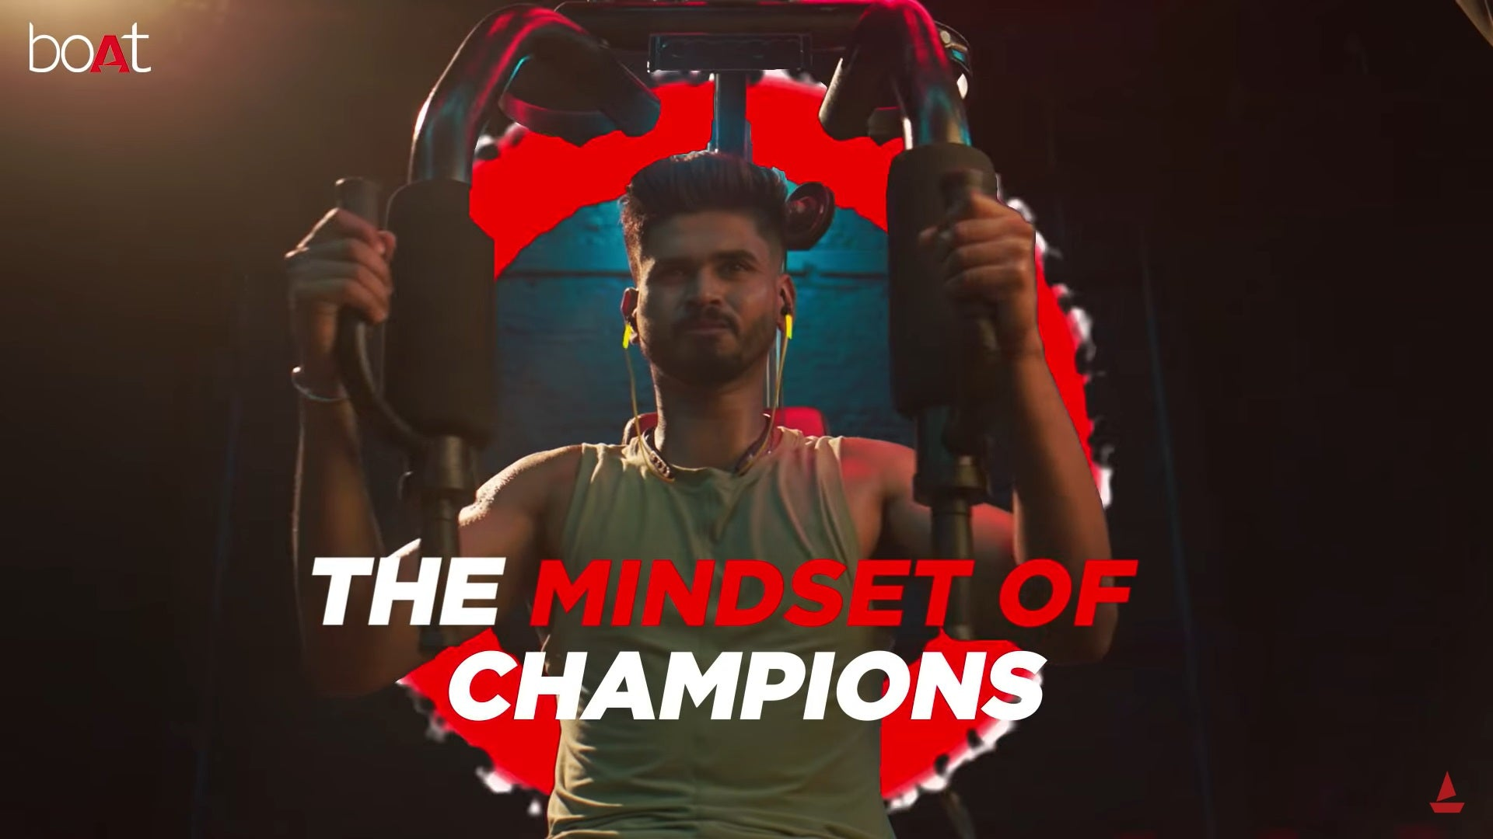

• Format: Carousel showing multiple product features.
Each slide highlights a feature like battery life, sound quality, or color options. Carousels are ideal for tech products because they allow deeper explanation.
• Targeting: Tech shoppers and music lovers engaging with gadget pages.
Instagram interest data helps boat reach users searching for headphones or speakers.
• Learning: Carousel ads educate users better and increase purchase intent.
Multiple slides give users more information, which is crucial for electronic products where features matter.
• CTA: “Buy Now”.
Direct CTA to drive e-commerce traffic during product launches.

- BYJUS:


• Format: Lead form integrated into Facebook.
The ad offers a free demo class and asks for name, phone number, and grade. Since the form opens inside Facebook, users don’t leave the platform, making signups easy.
• Targeting: Parents and students preparing for exams.
Byju’s targets parents aged 30 to 45, students aged 12 to 18, and learners engaging with education-related content.
• Learning: Reduced friction leads to more leads
Lead ads work well because Facebook auto-fills user information, reducing effort.
• CTA: “Sign Up”.
Encourages immediate lead capture rather than a purchase.

- AIRBNB:
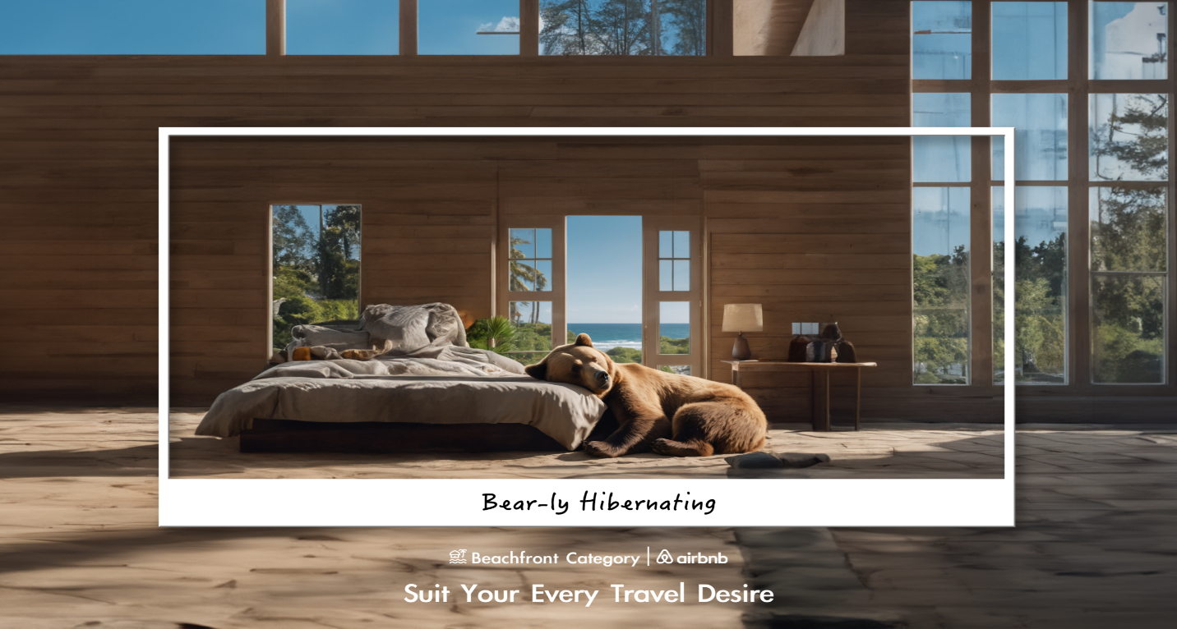

• Format: Full-screen immersive Story ad featuring a beautiful stay location.
A scenic video or photo covers the whole screen, creating a travel-inspired mood. Stories feel personal and grab user attention instantly.
• Targeting: Frequent travelers, people searching hotels, or following travel pages.
Instagram identifies users planning or dreaming about travel using browsing behavior and interests.
• Learning: Visual storytelling performs best in travel category.
People respond emotionally to scenic visuals. Story ads tap into FOMO and desire for travel experiences.
• CTA: “Book Now”.
Encourages users to check availability and book a stay directly.

